200.5

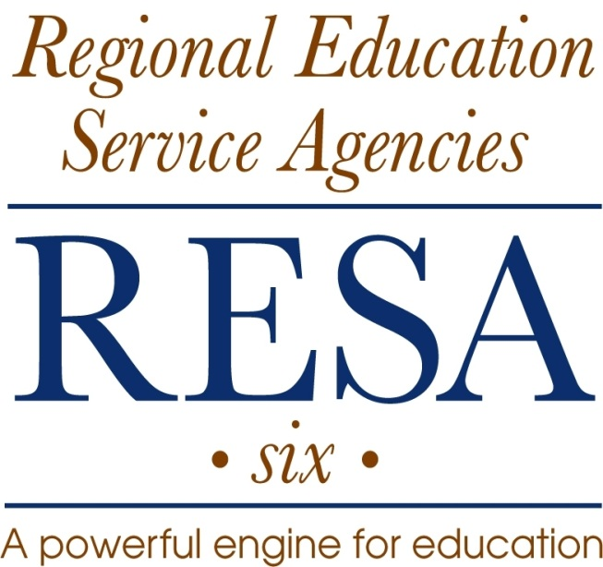

A PROGRAM OF

CORRECTIVE
DISCIPLINE

PHILOSOPHICAL BASE FOR CORRECTIVE DISCIPLINE

In the educational experiences presented to students, differences in personality, techniques, methodology, and interpersonal relationships between and among staff members are often desirable factors. However, when such differences give rise to patterns of unacceptable behavior or conduct on the part of individual staff members, education agencies are obligated to attempt to modify such behavior. This can be accomplished through the use of disciplinary procedures which are designed to correct such behavior. The primary objective of such a program is to promote and maintain a maximum level of acceptable behavior on the part of all staff members with the ultimate goal being to create the best possible learning environment for students.

Supervisors must be able to show that any disciplinary action taken is designed to be corrective rather than punitive. Action must serve to encourage the wrong-doer to correct inappropriate behavior and should lead ultimately to self-discipline. Consequently, CORRECTIVE DISCIPLINE becomes a tool to be used by supervisors to achieve and maintain the highest degree of professional conduct possible. This program also serves to encourage staff members as individuals and as a staff to maintain the high level of professional conduct expected of them.

A final obligation also exists for supervisors. If, after your supervisor has made a reasonable effort to correct the undesirable behavior or conduct of a staff member, that individual remains unwilling or unable to correct such conduct or behavior, the supervisor must pursue the necessary steps required for the orderly dismissal of the individual.

THE RESPONSIBILITY FOR CORRECTIVE DISCIPLINE
The supervisory representative of the Regional Council has an obligation to actively implement the RESA-6 policies in a positive manner. Inherent within this obligation is the responsibility to insure that the behavior and conduct of all staff members are acceptable and conducive to beneficial educational experiences for students.

Concurrently, the supervisor must accept their role in the implementation of the Corrective Discipline program for staff members when it becomes necessary.

Disciplining staff is a very unpleasant task; some even consider it demeaning. However, it is one of the obligations that must be accepted by supervisors if they are to meet their responsibilities. It should be of some encouragement to remember that such a program of discipline is not designed to be used with highly qualified and highly competent staff members. In all likelihood they will never experience disciplinary action. Corrective Discipline is designed to protect the great majority of staff who perform in a satisfactory manner. Likewise, it is a challenge to the ineffective, mediocre, insubordinate, unprofessional performance of those staff members who must improve or be dismissed.

Finally, supervisors cannot and must not ignore their responsibility to protect the public trust in, and credibility of, the educational standards of the region.

Due Process
“Due process” is the implementation of a PROCEDURE, which when adhered to guarantees the PROTECTION OF INDIVIDUAL RIGHTS. When applied to the Corrective Discipline process, this means there can be no surprises. The individual staff member must be made aware of what is expected regarding conduct, performance and behavior. Furthermore, the staff member must be guaranteed “fair” treatment when a violation occurs. The individual must be kept informed, and the supervisor must be able to prove this fact through appropriate documentation.

Due process also provides the right of objective determination of disputed questions of fact based upon established evidence. Simply stated, due process is the concept of “fair play.”

In the implementation of this process there must be adherence to the following tests:
- Was the rule, conduct, procedure or order KNOWN to the staff member and was it one that would be considered reasonable and related to the efficient, orderly operation of the workplace.
The word KNOWN in the first line is a key word. If action is to be taken against a staff member, if a reprimand is to be issued, if the employee is to be suspended for an infraction of a rule or for conduct unbecoming a member of the profession or not following a procedure or order, then, that rule, order or conduct, which is expected of the staff member must be made KNOWN to that individual. If an action is taken against a staff member because a rule was broken or a procedure wasn’t followed and the supervisor did not make the staff member aware of that rule or procedure, that supervisor is not being FAIR to that individual. What is expected of staff must be made know to them. There can be no “surprises.”
- Was the staff member notified relative to expected behavior in this regard and was there prior knowledge and indication of PROBABLE DISCIPLINARY CONSEQUENCES for failure to comply on the part of the staff member?
The phrase PROBABLE DISCIPLINARY CONSEQUENCES is the key to this test. The supervisor must not issue a written reprimand for being tardy if the supervisor has not orally warned the employee first. The employee cannot be suspended for unsatisfactory performance if the employee has not been orally warned or reprimanded in writing. Staff members should be WARNED that perhaps a more serious disciplinary action is going to be taken because they haven’t followed an order, a rule, a procedure, or conduct expected of them.

- Was there a fair and objective INVESTIGATION of the circumstances and the facts PRIOR TO the disciplinary action; and, in fact was there a clear violation or disobedient action?
INVESTIGATION and PRIOR TO are the key words in this test. In pursuing an action the administrator must conduct an investigation. That investigation has to be FAIR and it has to be OBJECTIVE.

- Is there specific data, DOCUMENTATION, and other information that exists to substantiate and verify the situation?
The key word in the test is DOCUMENTATION. There must be specific data and documentation. There is no substitute for such documentation. However, simply stated, professional judgment is not a substitute for specific data and documentation. To clarify, hearsay evidence is admissible provided it is closely related to information that has been documented, verified, and substantiated.

- Does the disciplinary action taken reflect a degree that is consistent with the seriousness and nature of the offense? Is it REASONABLE?
The key word here is the last one - REASONABLE. If a staff member is tardy a few times over a period of several months, and the supervisor sits down with that individual and states that a suspension is being recommended to the Executive Director, the staff member is likely to take the supervisor to task for that action. Such an infraction as being tardy a few times is not sufficient to suspend an employee. To orally reprimand the employee, that is, use a lesser disciplinary action, is satisfactory. If tardiness has occurred several times in a short period, the administrator may be able to justify a written reprimand. In summary, the action taken has to be consistent in degree with the seriousness of the offense.

Relationship of Just Cause and Due Process
An immediate reaction by supervisors to this process could be that it requires them to be trained legal authorities. However, closer examination demonstrates that it is a sound, logical and equitable procedure. Moreover, it is one which supervisors would mandate in their own situations should they be on the receiving end of Corrective Discipline.

It is important to remember that when a disciplinary action is taken both JUST CAUSE and DUE PROCESS are essential. One of these without the other will invariably mean that the disciplinary action will not be upheld by an arbitrator, hearing officer or a judge. To say it another way, the supervisor may have several proper reasons (just cause) to take a disciplinary action. However, should the supervisor fail to provide the guarantees of individual rights (due process) to the individual being disciplined, the supervisor’s action will be reversed or negated.

This concept can be summarized by the following flow chart:

JUST CAUSE DUE PROCESS DISCIPLINARY
ACTION

(Proper Reason) (Fair Play) (Oral Reprimand)
(Written Reprimand)
Protection of (Suspension)
(Show Harm) Individual Rights) (Dismissal)

THE PROGRESSIVE STEPS
IN THE CORRECTIVE DISCIPLINE PROCESS

Earlier sections of this manual have clearly indicated that the process of Corrective Discipline mandates certain requirements such as just cause and due process. Concurrently, the steps taken in Corrective Discipline must also be progressive in nature. For example, an initial incident of unauthorized absenteeism would not permit the step of discharge. Neither does each incident require that the total progressive process be followed in sequential order. The action taken should be determined by the specific aspects of each situation, by adherence to the requirements of Corrective Discipline, and by the use of logic and common sense.

However, notwithstanding the fact that Corrective Discipline is progressive, it should be emphasized that in certain circumstances, depending on the nature of the unacceptable conduct at issue, a first offense could be one for which the staff member could be discharged. Accordingly, the NATURE of the incident itself determines whether normal progressive steps of discipline are to be strictly followed. Therefore, there is no ironclad rule which indicates that disciplinary procedures must always follow a progressive route. It must be emphasized again that a firm concept to use as a guide is to ask assistance and seek advice if there is any degree of doubt involved.

The first of the progressive stricter steps in the Corrective Discipline process is the ORAL WARNING or ORAL REPRIMAND. This follows the investigation of the problem and the failure of counseling to solve it. The purpose of the oral reprimand is to document that a disciplinary action has been taken without tarnishing the employee’s record in the official personnel file. It is wise to make a record of such an occasion for future reference if needed.

The second step is the WRITTEN WARNING or WRITTEN REPRIMAND. There are certain elements that must be included in such a document. A supervisor can use this occasion to make reference to the oral warning that has occurred. The document must contain what happened, what is the reason for the reprimand, what is expected, and what will take place if it is not corrected or if such incidents arise in the future. The supervisor should be specific, to the point, and explicit. The supervisor must avoid moralizing, philosophizing, rationalizing, and flowery, “educationalese” language.

The third step is SUSPENSION WITH PAY or disciplinary time off with pay. This is legally interpreted as a major warning to the staff member Suspension or disciplinary time off is considered as a very serious disciplinary action. The amount of time off is a short period, usually one day.

The fourth step is SUSPENSION WITHOUT PAY or disciplinary time off without pay. The duration or period of disciplinary time off without pay should be determined by the severity of the particular situation under consideration. Experience with this situation indicates such duration would not exceed one week.
The final step in Corrective Discipline is DISMISSAL or termination of the staff member’s employment. It is corrective in the sense that it is the final resolution to a problem and could prevent similar behavior on the part of other staff members.

There are five general areas that cause the onset of Corrective Discipline. These five include:

- NEGLECT OF DUTY
Each employee is expected to be on duty during regular work hours and to fulfill the responsibilities of the employee’s position. If not, the employee is not doing the job.
- INSUBORDINATION

Although this runs the total continuum of behavior, it is basically the failure to follow a clear and reasonable order, request, or directive.

- FAILURE TO PERFORM DUTIES PROPERLY

An employee has the ability and experience to do the job; but, for some reason, the employee isn’t getting the job done.

- IMPROPER CONDUCT

Written and unwritten expectations of conduct on the part of all employees exist in the RESA’s policies, rules or guidelines. When an employee violates these conduct expectations, there is need for Corrective Discipline.

- INCOMPETENCY

An employee does not have the innate ability to successfully complete an assigned task.

Three major points need emphasis:
- The concept of DUE PROCESS or protection of individual rights is a MUST in the DOCUMENTATION process.
- There is only one OFFICIAL file – the file maintained in the Executive Director’s office.
- MOST importantly, under no circumstances can there be SECRET FILES or NOTES!

The following concepts have been presented in detail:

- Supervisors are representatives of the Regional Council. Therefore, they must maintain the posture of managers and members of the total management team.
- Supervisors must know RESA policies applicable in the process of Corrective Discipline.
- Supervisors must provide, to all staff members, the rules and regulations that are applicable to them and ascertain that staff members understand such rules and regulations.
- Supervisors must provide an objective procedure for the fair administration of all rules and regulations and see to it that the staff members understand that such administration will be fairly undertaken.
- Supervisors should seek appropriate assistance with regard to any disciplinary situation.
- Supervisors must build a record with regard to each and every disciplinary situation.
- Supervisors must exercise prompt, firm, and just treatment with regard to all disciplinary procedures and must establish in the minds of the staff the fact that such a position will be maintained consistently with regard to all staff members.

Supervisors should review and turn to this document when discipline of a staff member is contemplated or becomes necessary. It should assist supervisors in proceeding in a manner that will help to correct unacceptable behavior, and when no option remains, it will assist administrators to take the necessary steps required for the orderly dismissal for the individual.

