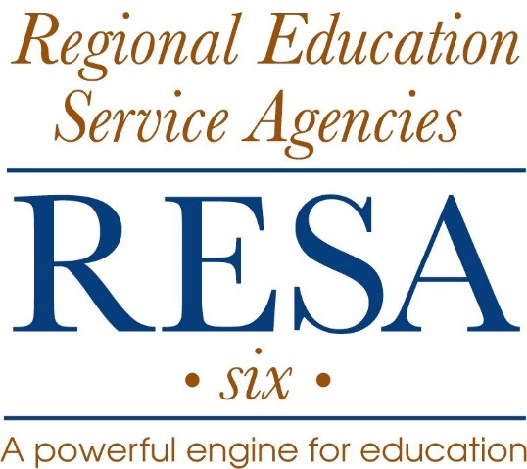
Appendix 1 100.0
Regional Education Service Agency VI

Policy Manual

Employee Acknowledgement Form

__________________________________________have read and understand the contents of this Employee
(Name)
Handbook. I further understand it does not constitute a contract for employment, and acknowledge that I

understand I am an at-will employee. Further, I understand the contents of this handbook can change, and I

will be timely apprised of any changes.

Signature __________________________________________________

Date ______________________________________________________

Executive Director Signature __________________________________

