**New** RESA 6 Action Research Projects for 2016-2017

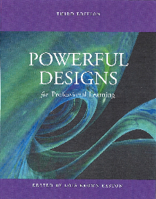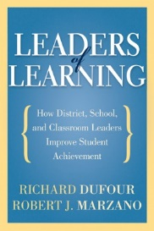

Powerful Designs for Professional Learning; Design learning experiences that change teacher practices and get results for students.

Leaders of Learning; How District, School, and Classroom Leaders Improve Student Achievement

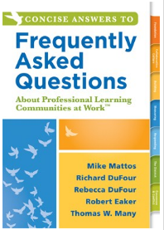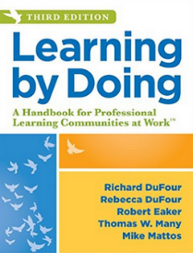

Learning by Doing; A Handbook for Professional Learning Communities at Work

F.A.Q. Learning by Doing; About Professional Learning Communities at Work

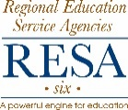

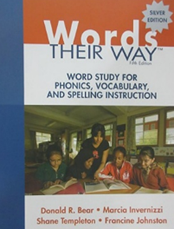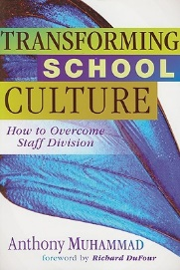

Words Their Way; Word Study for Phonics, Vocabulary, and Spelling Instruction

Transforming School Culture; How to Overcome Staff Division

Previous Year’s Action Research Projects:

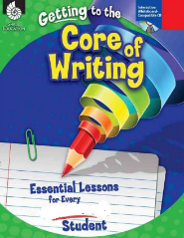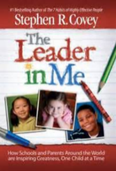

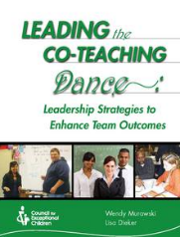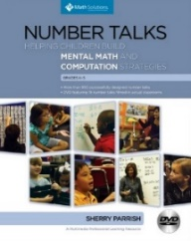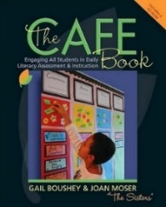

Titles from left to right: *Engaging Students with Poverty in Mind, Making Thinking Visible, Boys and Girls Learn Differently, The Daily 5, The Café Book, Number Talks, Leading the Co-Teaching Dance, The Leader in Me, and Getting to the Core of Writing*

**Note:** An Action Research Project does not have to be centered on a book. Other successful ARPs from recent years have been focused on well-specified topics such as iPad Training or Technology Integration in the Classroom. All that is needed is a clear focus on topic and a well-developed syllabus.